Movie Landing Page Website Design

Name : Mande Ramamohana Reddy

Mail Id : ramumande66@gmail.com

Phn No : 8106392035

Roll N0 : 20HU1A0429

College Name : Chebrolu engineering college

**Source Code:**

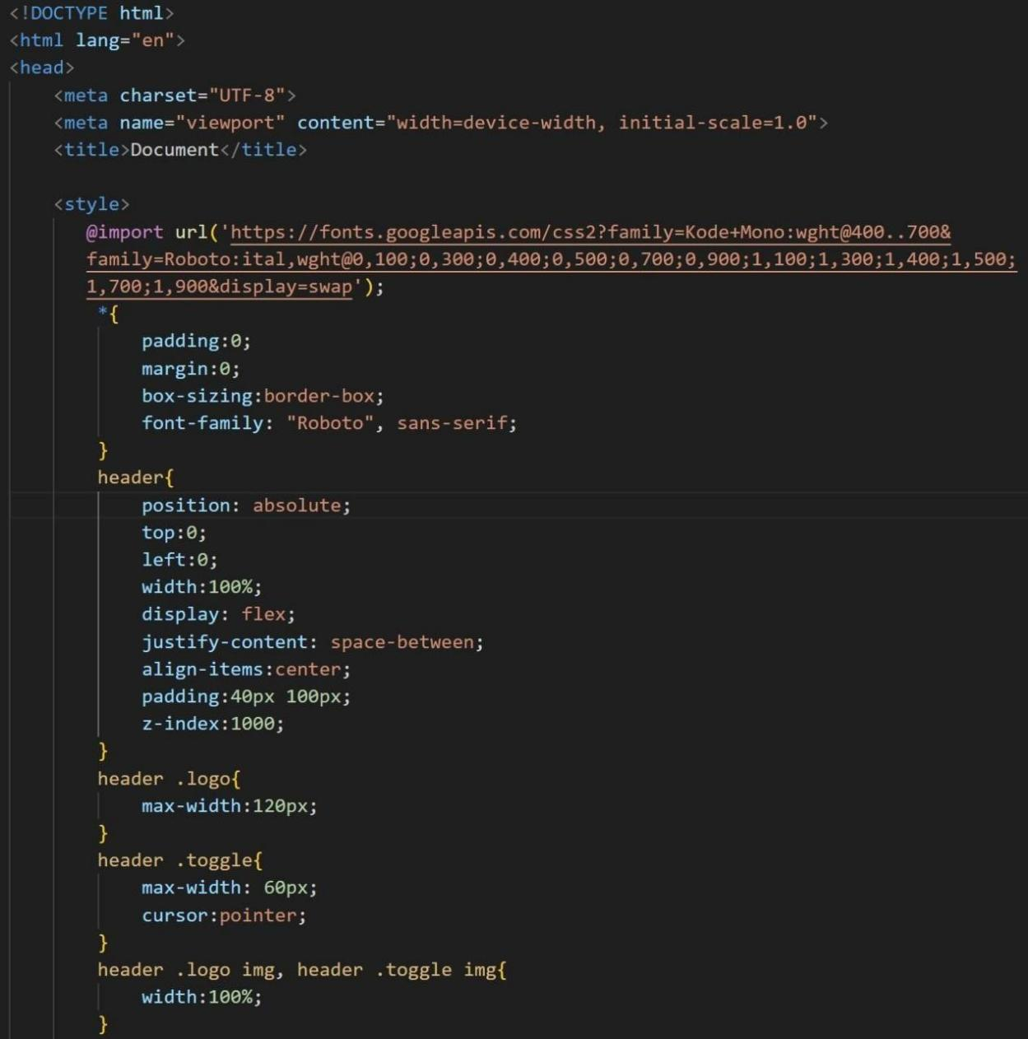

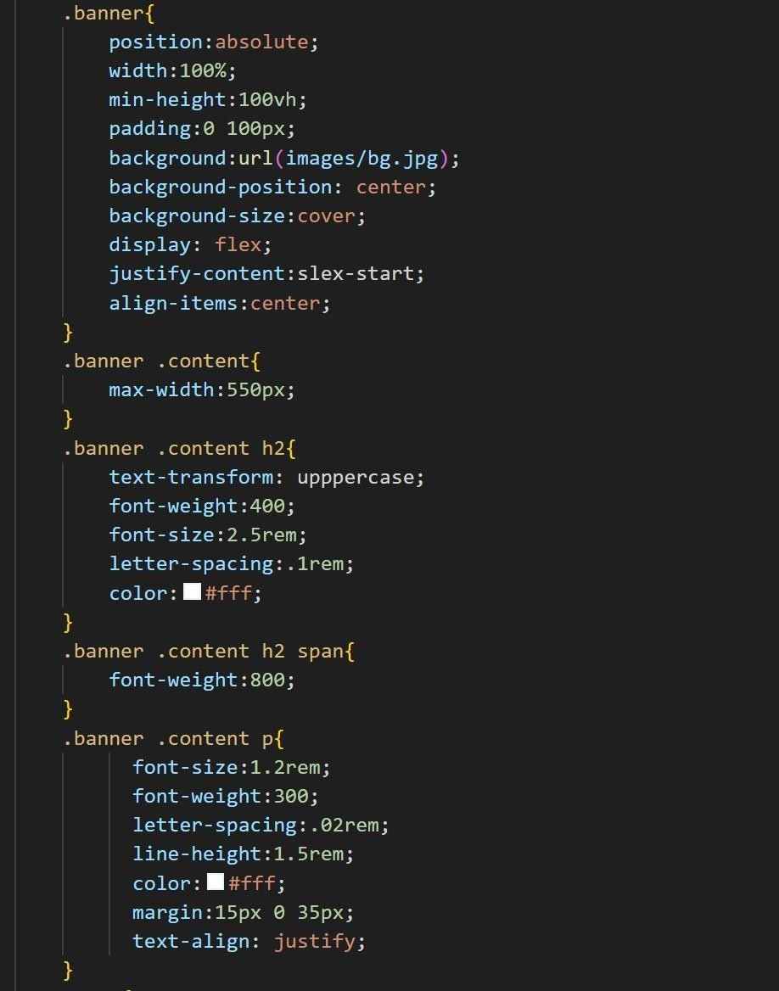

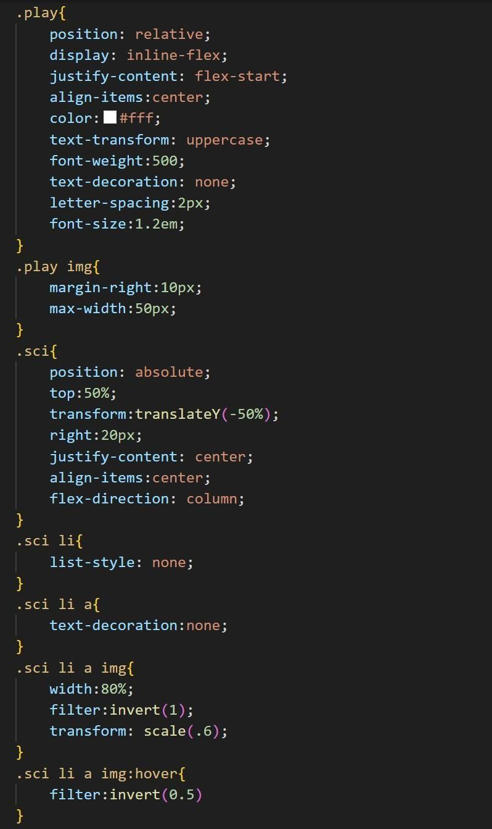

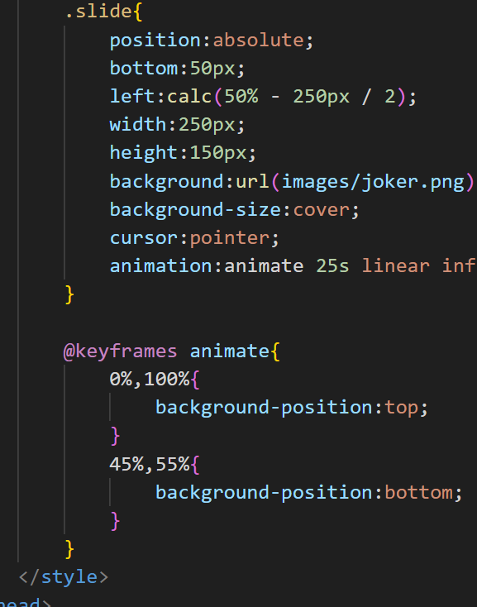

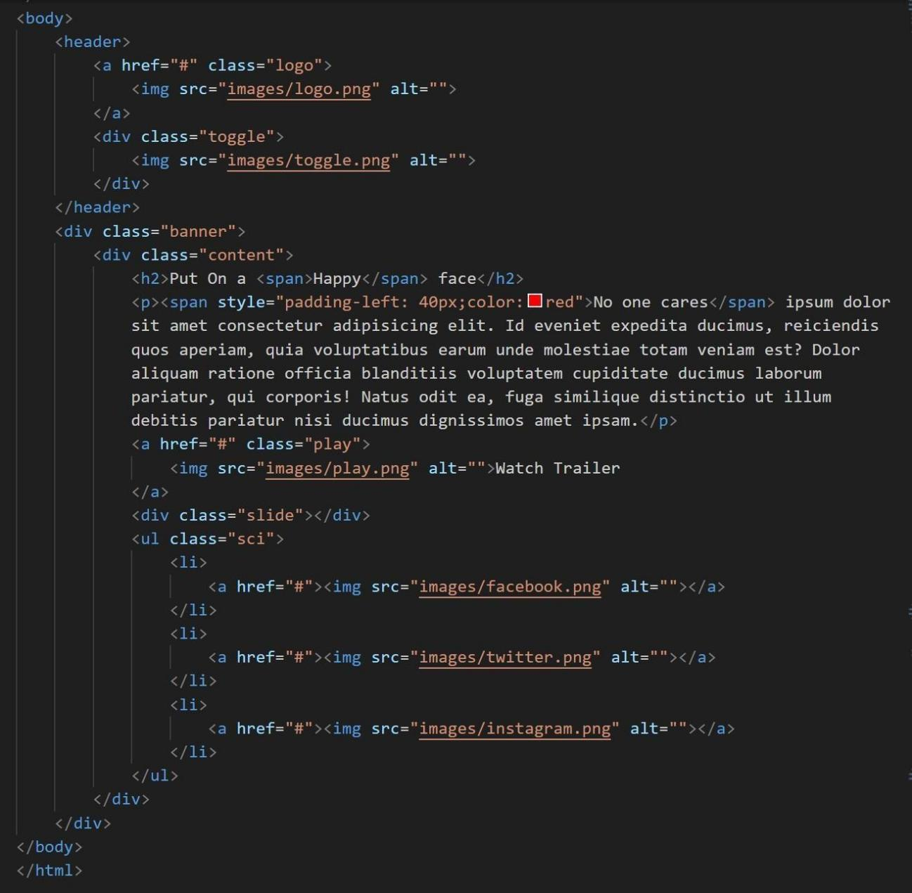



**Output :**